JOB AID- SMART Meter Ship file validation & provisioning

  - Consumers Energy – Enhanced Operations Rel. 4a
PJT03222.SAP.DM.JA.ZDM_ESN_DeProvision
09/18/2014
By Legodile Kwapa

Section 1 - Intent of transaction ZDM_ESN_DEPROVISION- Smart Device DeReg/Deprovisioning:

The Smart Device DeReg/Deprovisioning – transaction code ZDM_ESN_DEPROVISION can be used to de-register and de-provision meters in Open Way Collection Engine (OWCE) based on the mode selected in the transaction.

The Acquisition lot mode triggers a web service to de-register meters from OWCE. The Recycle lot mode triggers a web service to de-register and then remove the meters from OWCE.

This transaction should only be used on an ad-hoc basis, as there are automated process triggers for both De-Registration and De-Provisioning..
De-registration is automated by a follow-up action that is part of Acquisition inspection lot usage decisions.
De-Provision automated by a daily Redwood job, that will de-provision the meters from the day before.

The web service performs two functions:
- De-Registration of the End Points (meters) in OWCE
- Removal of End Points (meters) in OWCE

When meter are De-Provisioned the removal of the ISM key in Open Way Collection Engine (OWCE) is a manual step. The removal of ISM keys should always be performed after the end point definitions are removed from OWCE.

Prerequisite:
- The meter should be SMART meters.
- The SMART meters should have the Meter ESN field should be populated.
- The SMART meters must be registered and provisioned in OWCE.
- For SMART meters associated with an inspection lot. The results recording should have been completed.
- The SMART meters should have a user status of
  - 58 - Retired No test/scrapped
  - 59 - Retired with Test /scrapped
  - RMR - Return to Vendor

Section 2: Process steps:

# | Section | Step # |  | Dept. |  | Description | Notes
Execute transaction ZDM_ESN_DEPROVISION |  | 1 | MTC |  | Enter transaction ZDM_ESN_DEPROVISION and press enter
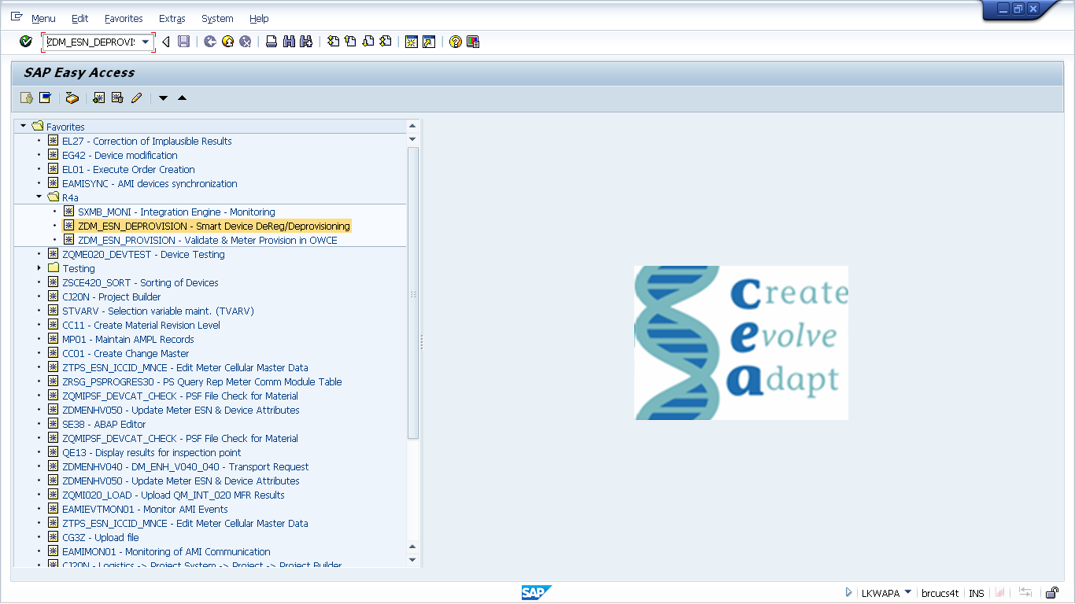

Option for Acquisition Lot

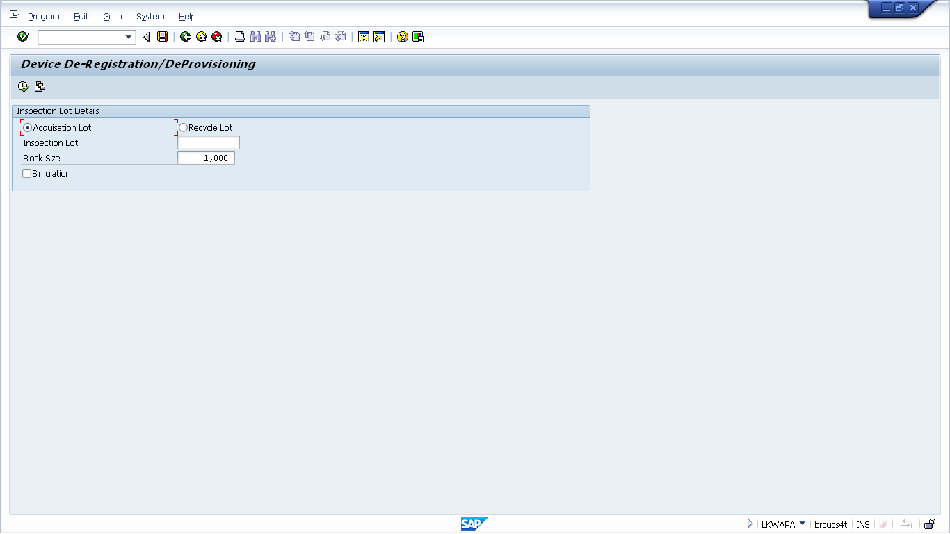

Option for Recycle Lot

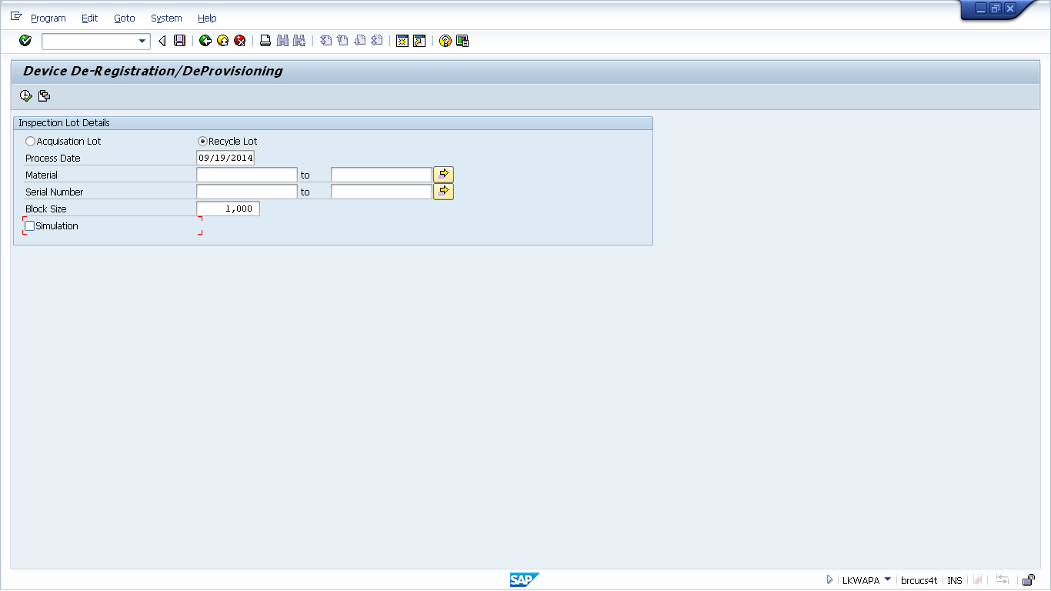

Option for Acquisition lot | 1a | MTC | Processing the inspection lot associated with an Acquisition Lot will trigger the web service to de-register the meters associated with the inspection lot. | Results recording must have been complete for the inspection lot.
 | 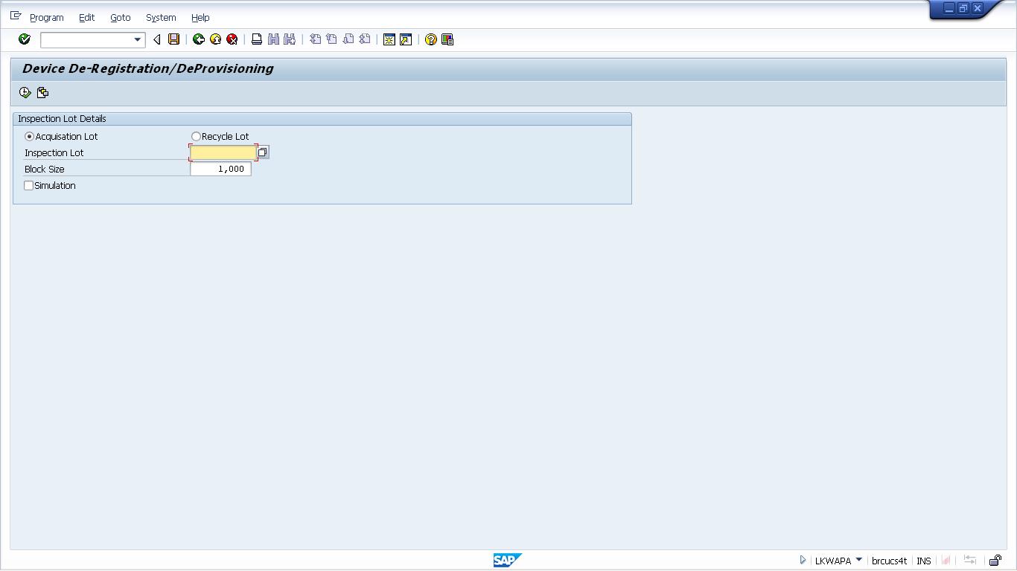
 | 1b | MTC | Click on the execution icon (short-cut: F8). | Remove the Simulation flag before execution
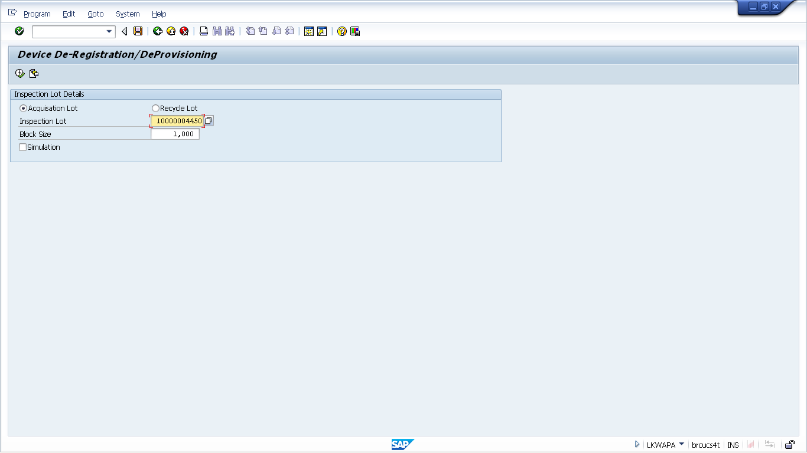
Option for Acquisition lot

 |  | 1c | MTC | A confirmation will be shown after the transaction is executed.
 |  | 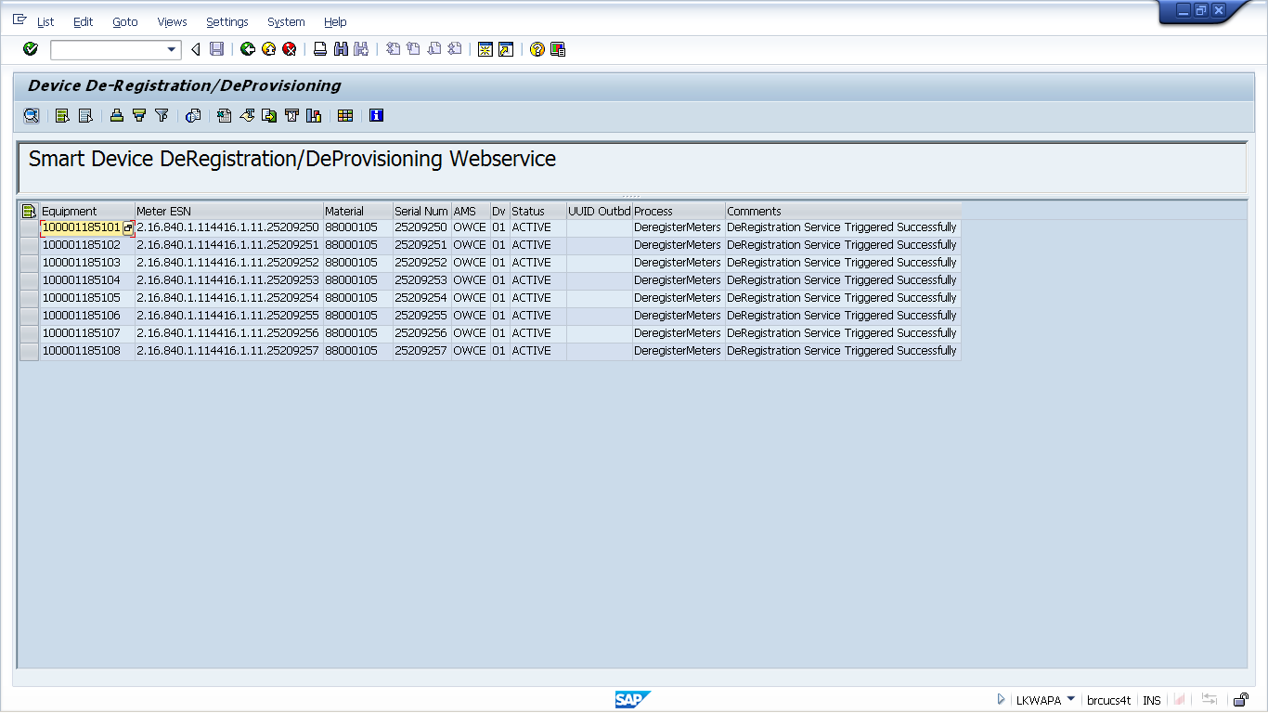
 |  | 2a | MTC | To process meter associated with a recycle lot. Click the radio button for recycle lot.
 |  | 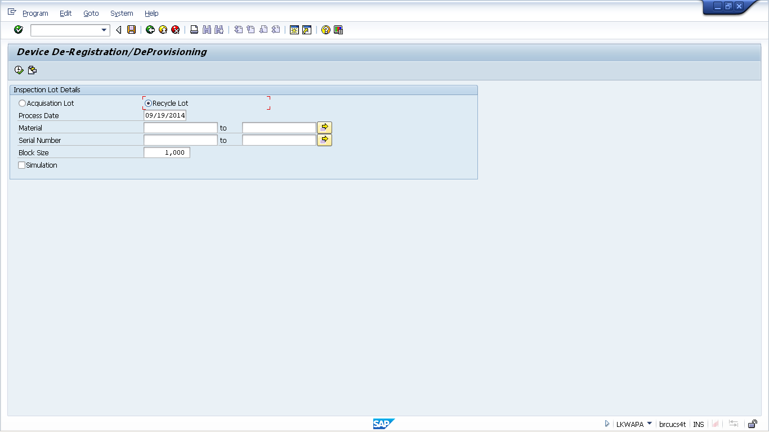
 |  | 2b | MTC | Enter the material and the serial number (s) for the meters associated with the recycle lot
 |  | 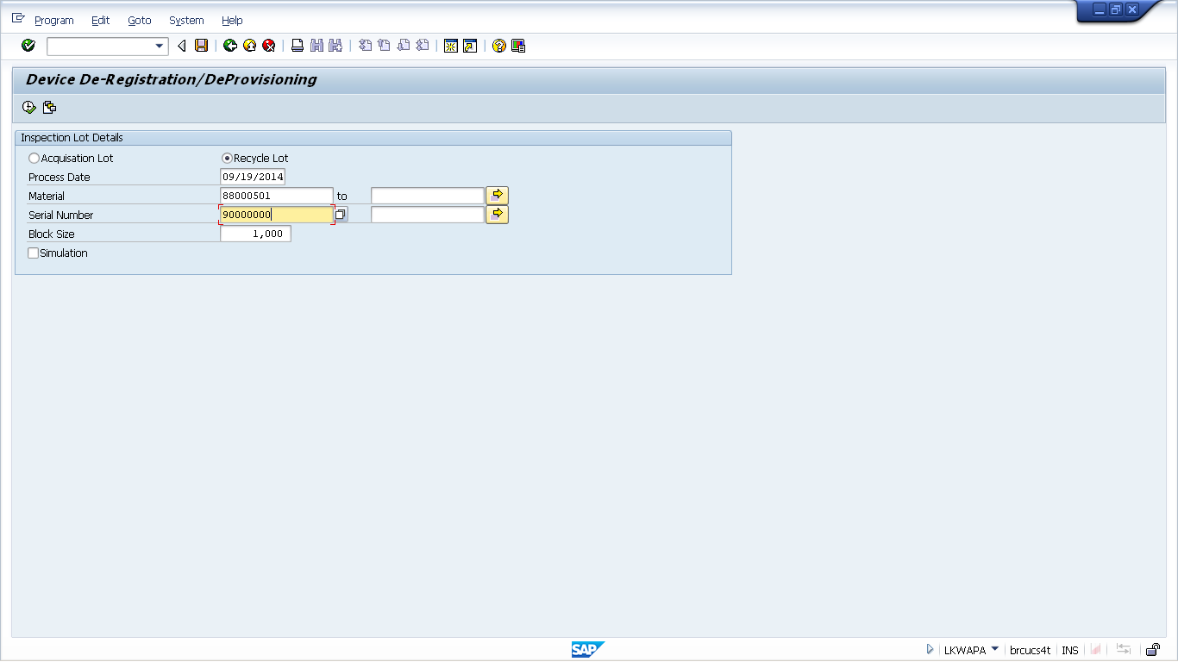
 |  | 2c | MTC | Click on the execution icon (short-cut: F8). | Remove the Simulation flag before execution
 |  | 
 |  | 2d | MTC | Online confirmation that “DeRegistration Service Triggered Successfully”
 |  | 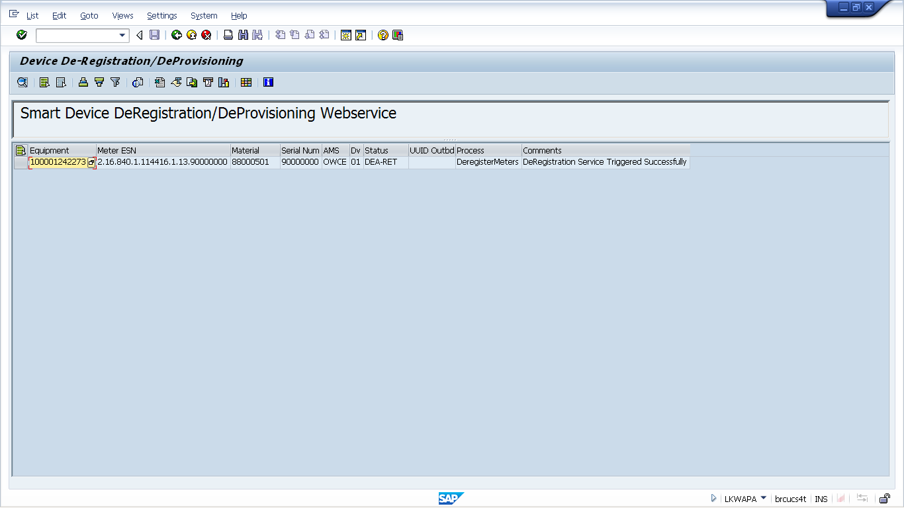
 |  | 3 | MTC | For both options, an email confirmation will be sent to the Joint MTC-SEOC P.O. Box.

Revision History
Version | Author(s) | Date | Significant Changes
0.1 | Legodile Kwapa | 09/18/14 | Initial Draft

